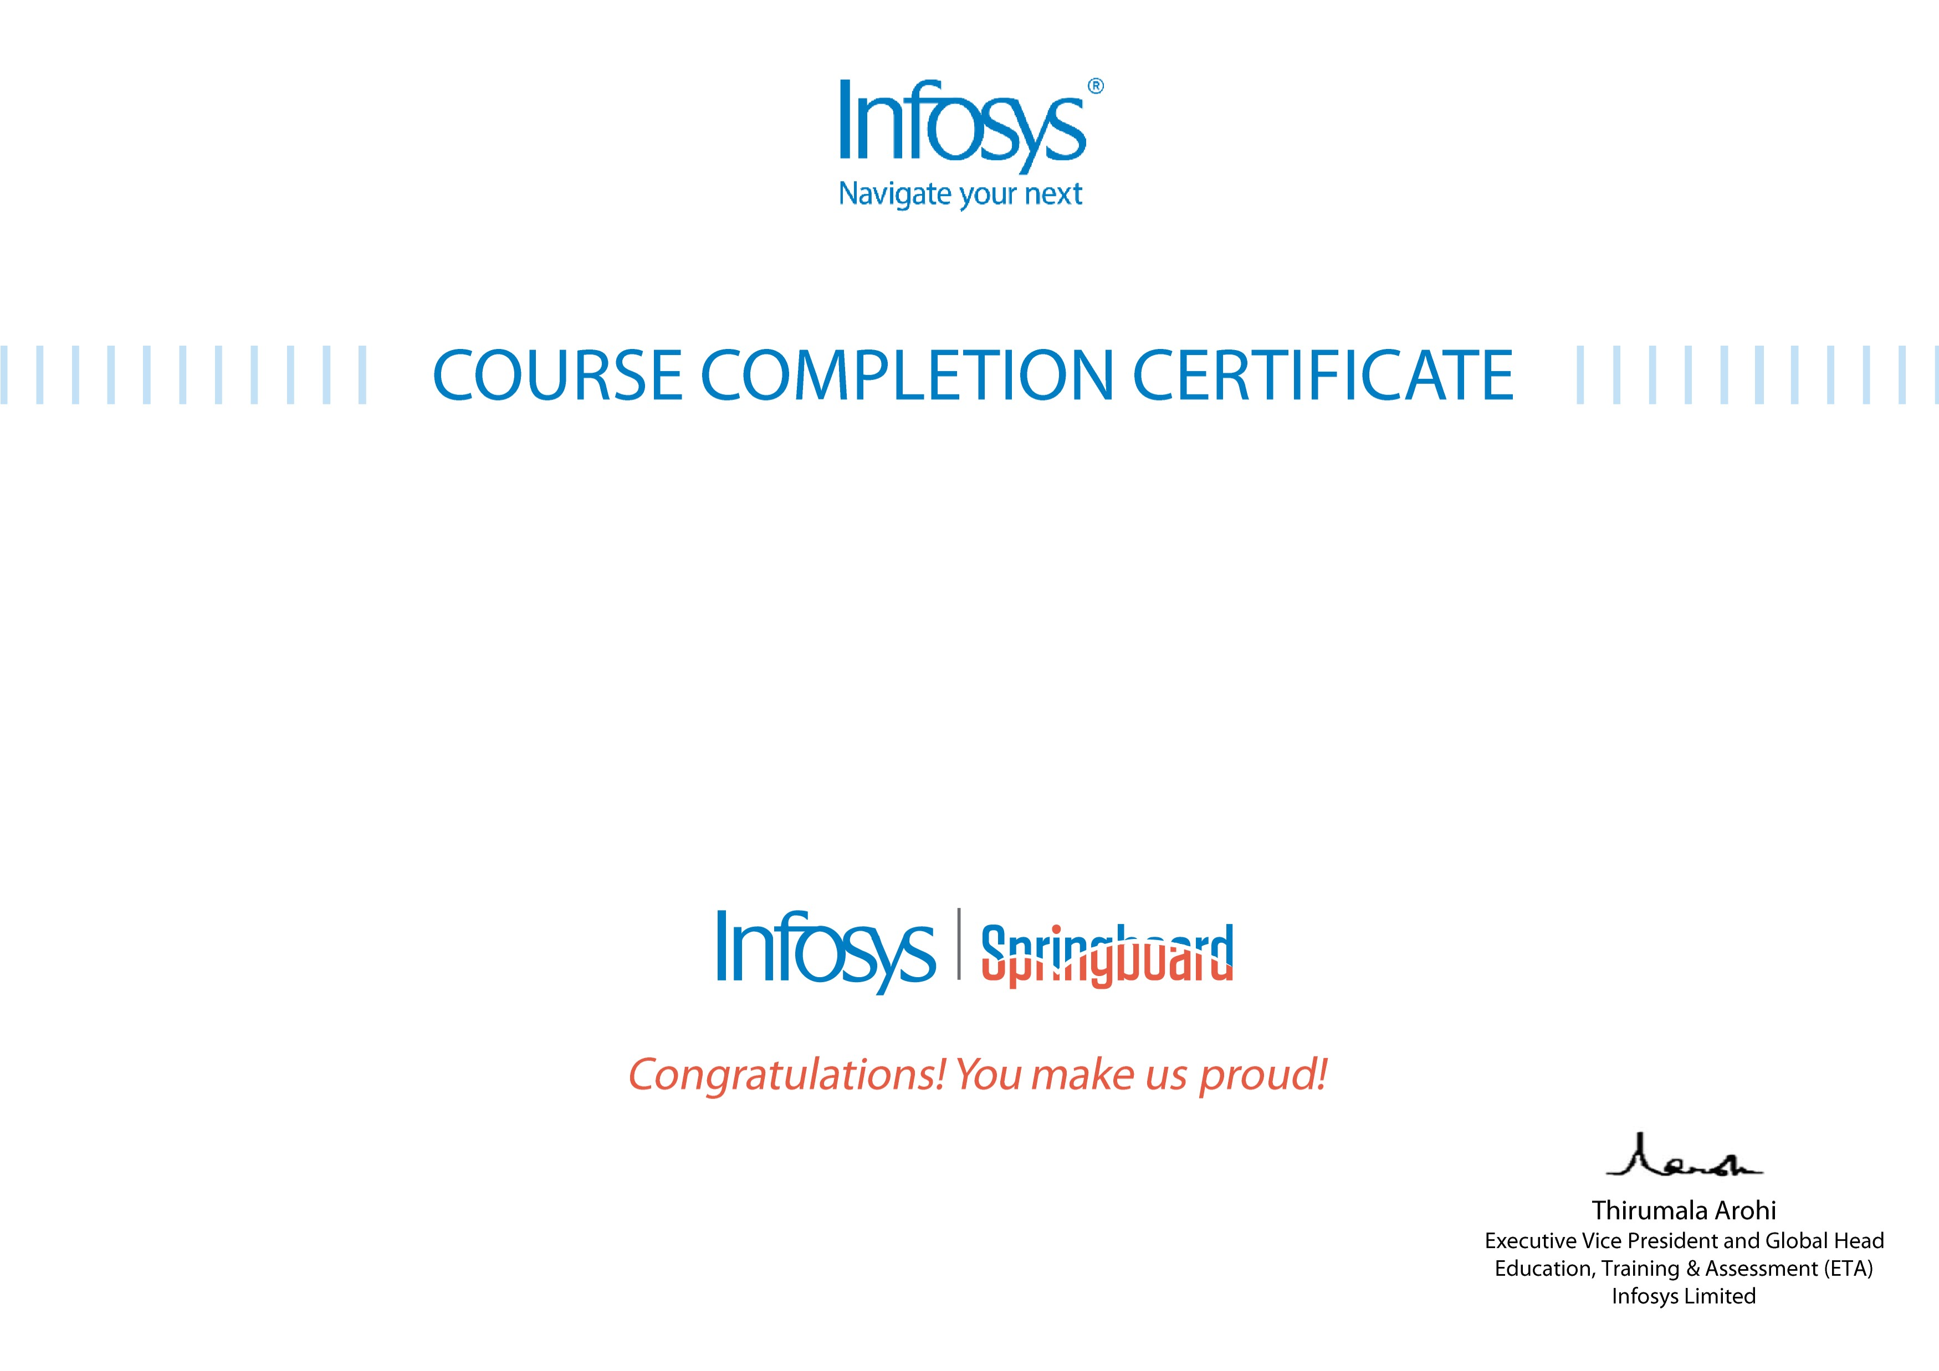
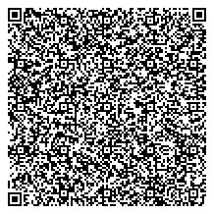
Om Deshmukh
Experiment5 - Traffic Light System[Centrado Kit]
The certificate is awarded to
for successfully completing the course
on July 9, 2024
Issued on:
Tuesday, July 9, 2024
To verify, scan the QR code at
htt
p
s://verif
y
.onwin
g
span.co
m

